**Learn about the Course 1 TikTok workplace scenario!**

This end-of-course project was designed with you in mind, creating an opportunity for you to practice and apply your data analytic skills. The materials provided here will guide you through discussions with co-workers, internal team members, and external stakeholders.

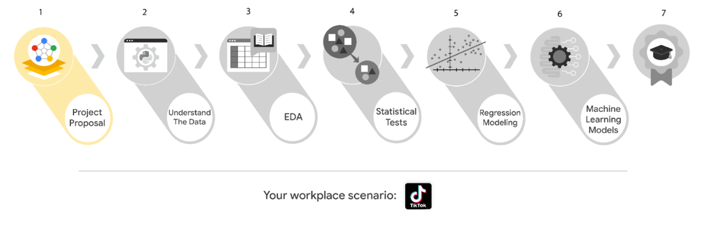

Learn more about the project, your role, and expectations in this reading.

**Background on the TikTok scenario**

Welcome to your new role at TikTok! We’re thrilled to have you on the data team!

At TikTok, our mission is to inspire creativity and bring joy. Our employees lead with curiosity and move at the speed of culture. Combined with our company's flat structure, you'll be given dynamic opportunities to make a real impact on a rapidly expanding company and grow your career.

TikTok users have the ability to report videos and comments that contain user claims. These reports identify content that needs to be reviewed by moderators. This process generates a large number of user reports that are difficult to address quickly.

TikTok is working on the development of a predictive model that can determine whether a video contains a claim or offers an opinion. With a successful prediction model, TikTok can reduce the backlog of user reports and prioritize them more efficiently.

**Project background**

TikTok’s data team is in the earliest stages of the claims classification project. The following tasks are needed before the team can begin the data analysis process:

* A project proposal identifying the following:
  + Organize project tasks into milestones
  + Classify tasks using the PACE workflow
  + Identify relevant stakeholders

**Your assignment**

For your first assignment, TikTok is asking for a project proposal that will create milestones for the tasks within the comment classification project. Remember to take into account your audience, team, project goal, and PACE stages of each task in planning your project deliverable.

**Team members at TikTok**

As a new data analyst, you’ll work closely with a talented team of experienced data professionals. You’ll also collaborate with TikTok co-workers outside the data team as your project requires.

**Data team roles**

* Willow Jaffey- Data Science Lead
* Rosie Mae Bradshaw- Data Science Manager
* Orion Rainier- Data Scientist

**Cross-functional team members**

* Mary Joanna Rodgers- Project Management Officer
* Margery Adebowale- Finance Lead, Americas
* Maika Abadi- Operations Lead

***Note:*** *The story, all names, characters, and incidents portrayed in this project are fictitious. No identification with actual persons (living or deceased) is intended or should be inferred. The data shared in this project has been altered for pedagogical purposes.*

Your TikTok team includes several managers overseeing operations. It is important to adapt your communication to their roles since their responsibilities are less technical. The members of the data team at TikTok are well versed in data analysis and data science. Messages to these more technical co-workers should be concise and specific.

**Meeting notes**

Now that you are onboard, you have access to the company network and are set up with a company email account.

You notice an email from your supervisor at the top of your inbox.

**From:** Rosie Mae Bradshaw

**Subject:** Your first task: Review meeting notes

If you are able to read this, then your company accounts have been created! It’s the perfect time to get started with your first task. Last week, I attended an internal meeting with our leadership team about a new project we are about to begin. You’ll receive more information in the next few days, but I would like you to be aware of some needs that were identified by our leadership. Here is an excerpt from the notes I took during the leadership team meeting. I’ve organized the points by the individual who made the comment:

Mary Joanna Rodgers- Project Management Officer

* The project will need a global document identifying deliverables & milestones.
* We will need to generate some visuals to share with TikTok executives.

Orion Rainier-Data Scientist

* We will need to have an understanding of the data we will be working with on this project.
* It will require someone on the team to inspect the dataset for missing data.
* The data team needs to determine what information will be the most useful in TikTok’s data through exploratory data analysis (EDA).
* Eventually, our team will need to run some method of statistical testing.

Willow Jaffey- Data Science Lead

* The goal of the claim classification project is to build and deliver a reliable machine learning model.
* The team will need to determine the type of regression model for this project.
* Once we have a final model, I'll need to know the main talking points going into our presentation to the leadership team.
* The team will need to determine the best method of hypothesis testing for this dataset.

My thoughts and concerns…

* I think it's best to use Python for this project. I'll have someone on my team set that up as soon as we have the project proposal in place.
* I'd suggest the data team will need to check the assumptions made by any regression modeling developed for this project.
* The data team will identify and set up the project’s workflow.

There will be more details sent to you very soon.

Welcome to the team,

Rosie Mae Bradshaw

Data Science Manager

TikTok

*(P.S. Don’t forget about the company-sponsored lunch on Friday. The food is always fantastic. It’s a great opportunity to meet more of our wonderful co-workers. Our team meets in the lobby around noon. Please join us!)*

**Specific project deliverables**

With this end-of-course project, you will gain valuable practice and apply your new skills as you complete the following deliverables:

* Course 1 PACE Strategy Document to plan your project while considering your audience members, teammates, key milestones, and overall project goal.
* Create a project proposal for the data team.

**Key takeaways**

The Google Advanced Data Analytics Certificate end-of-course project is designed for you to practice and apply course skills in a fictional workplace scenario. By completing each project, you will have work examples that will enhance your portfolio and showcase your skills for future employers.